<https://progresslink.progress.com> to create a new account:

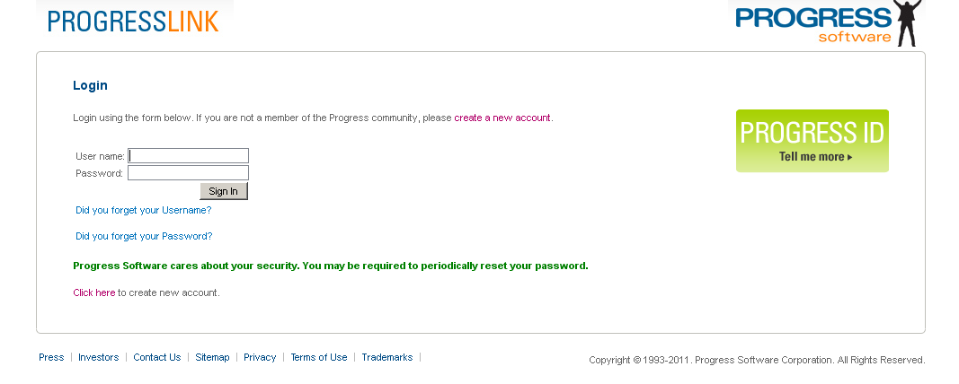

1. On the screen above, select, “Click here to create a new account”. You will then be presented with a long web form to complete. Select your own username and password.

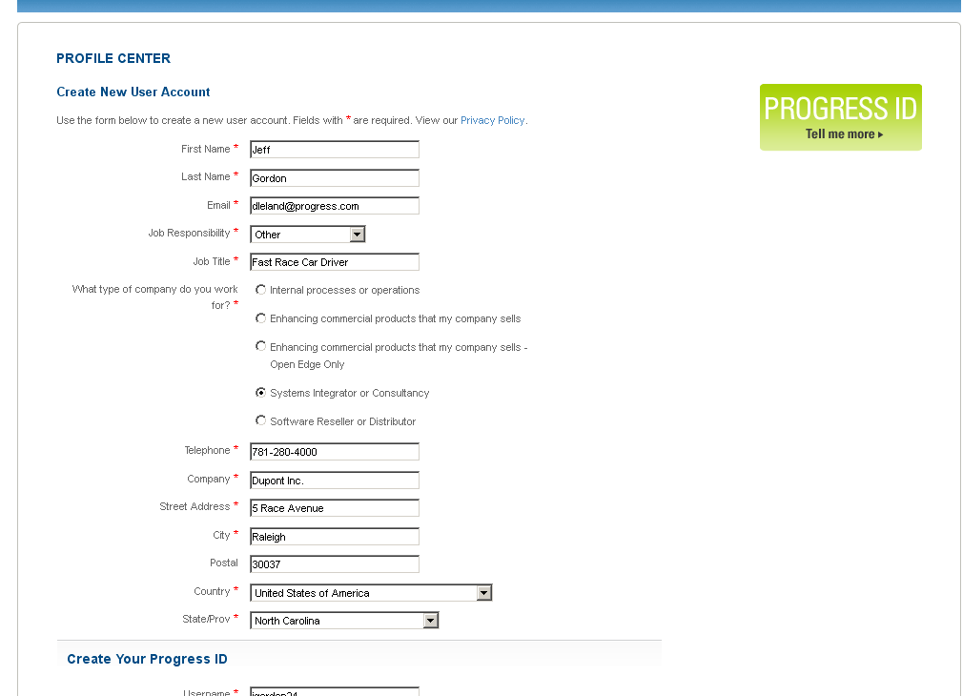

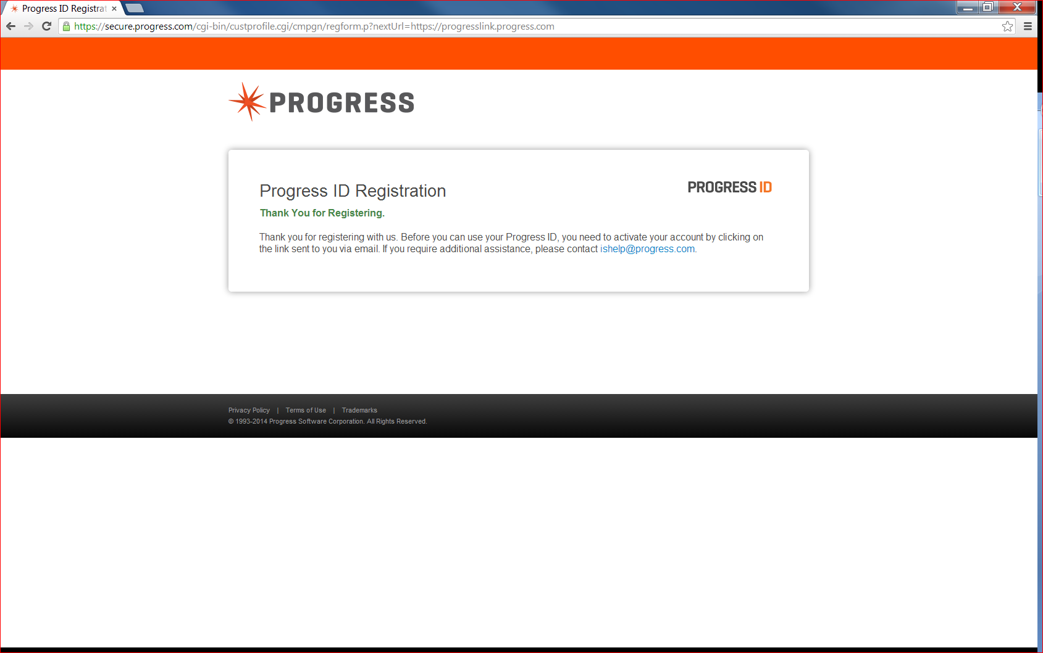

1. After completing the long web form, you will receive a confirmation email. Open it and click on the Activate My Account option:

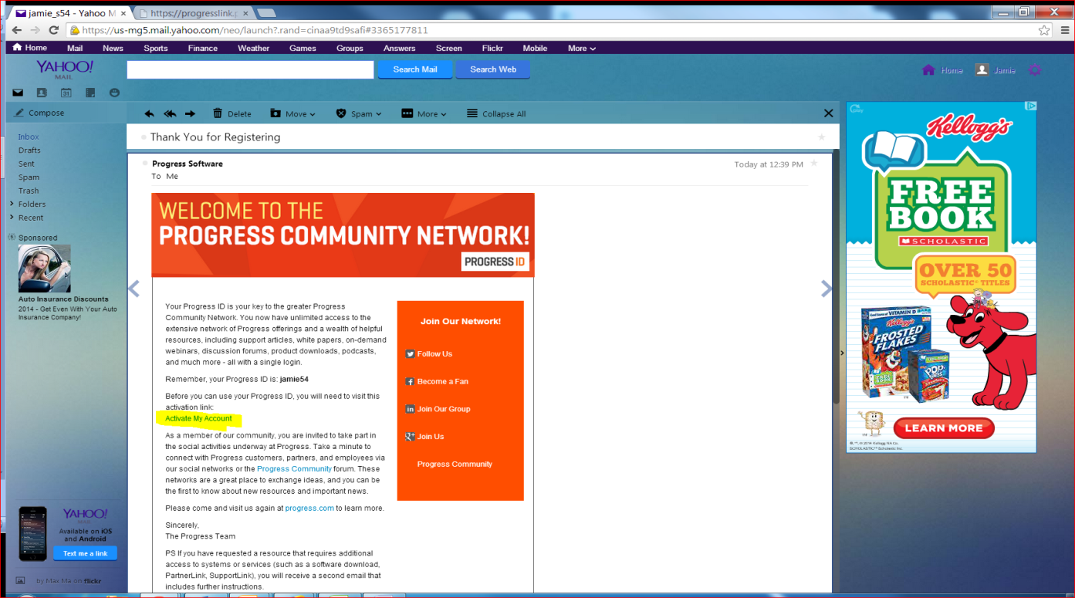

*Note: Once you click on the “Activate My Account” link in the email, you will be redirected to the* [*https://progresslink.progress.com*](https://progresslink.progress.com) *site where you will then login with the credentials you just created on the registration form*.

1. You will then be presented with the “Access Request” page and you should select, “Progress SupportLink” in order to request access to SupportLink.

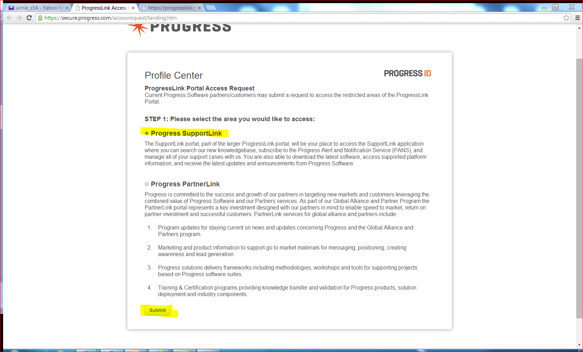

1. Once you selects, “Progress SupportLink” and clicks submit, you will be brought to another webpage where you will need to supply either a valid customer number or valid serial number to be entitled to SupportLink and Service Cloud. 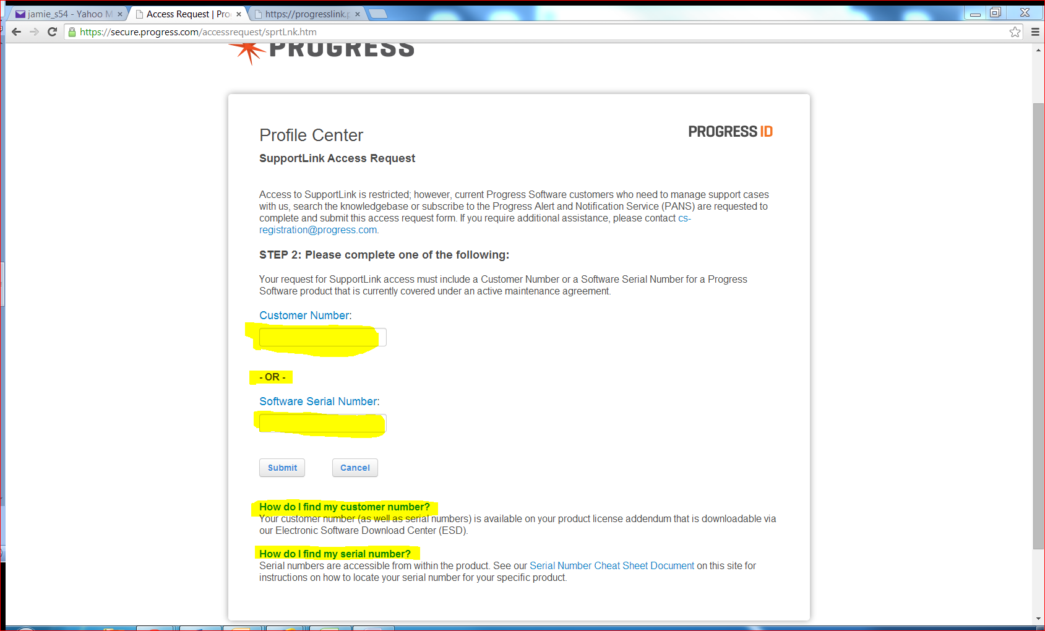

5. Enter one of those and click Submit. At this point you will receive the following message:

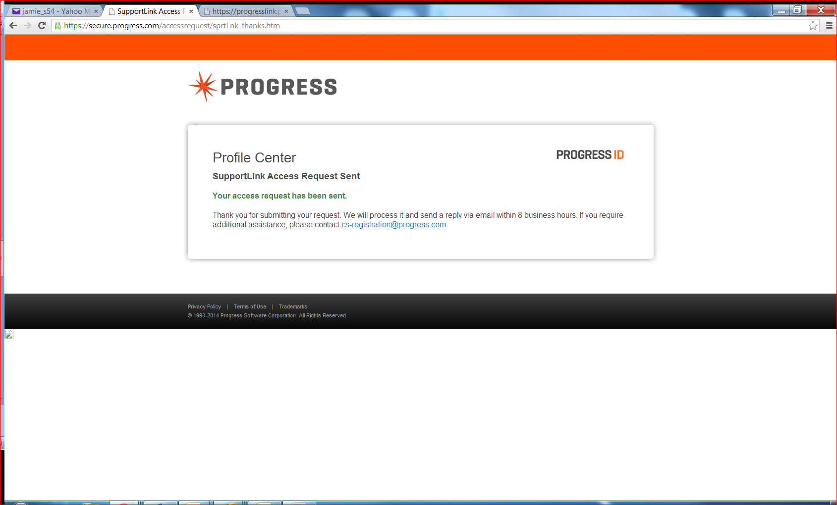

The approval for this may take up to 8 hours, but in most cases only takes an hour or two to be returned. Once you receive the approval, you will have access to SupportLink using the userid and password you selected.